Catalog

**Lich(3 variation)**

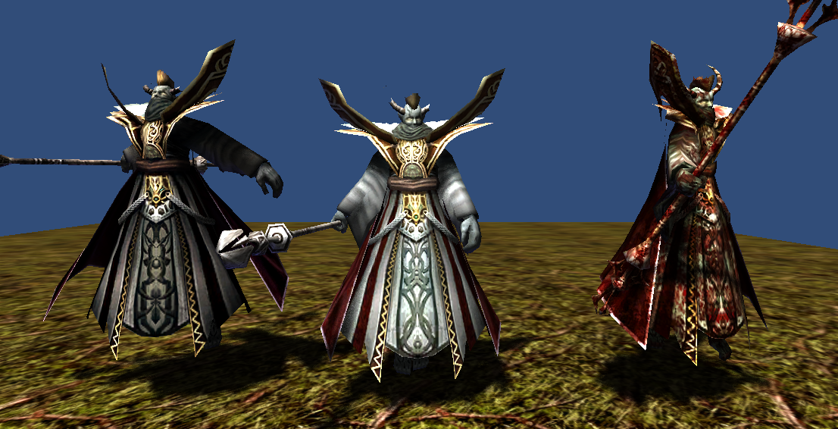

1792 polygons

512x512x32bit 1 texture

5 animations(idle, move, attack, beaten, die)

**Smilodon(4 variation)**

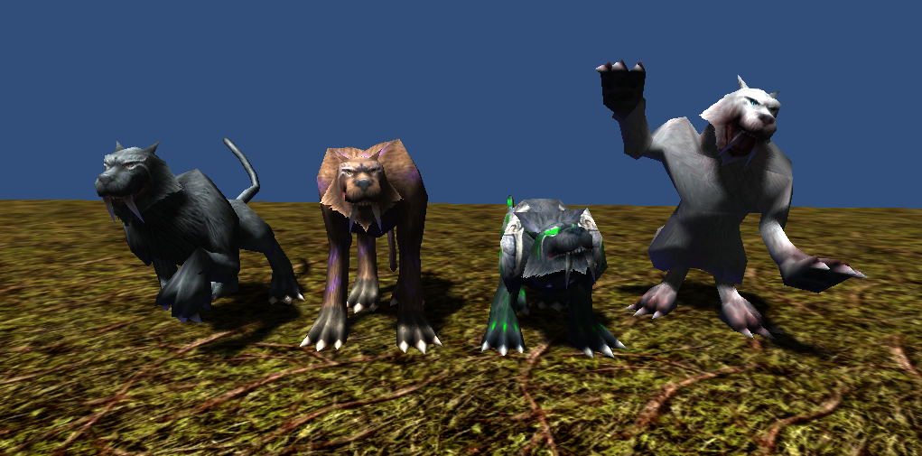

786 polygons

512x512x32bit 1 texture

6 animations(idle, move, attack1, attack2, beaten, die)

**Goblin(4 variation)**

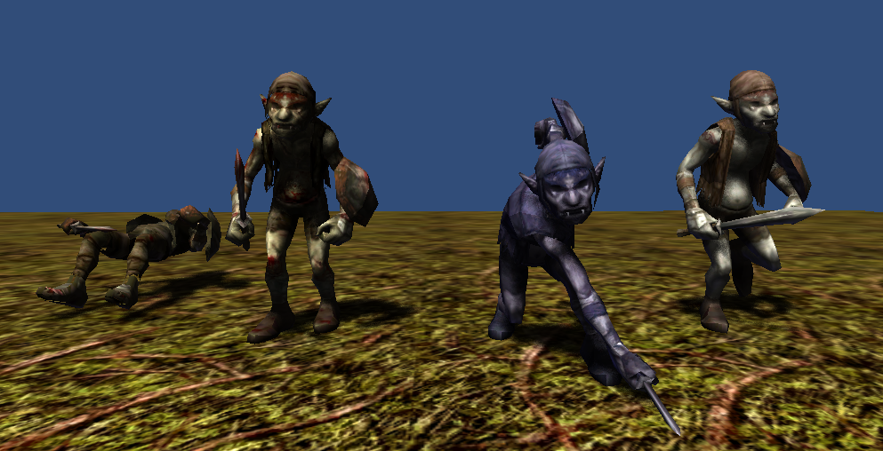

1824 polygons (runner 1824 polygons)

512x512x32bit 1 texture

6 animations(idle, move, attack1, attack2, beaten, die)

**Vehimorse(4 variation)**

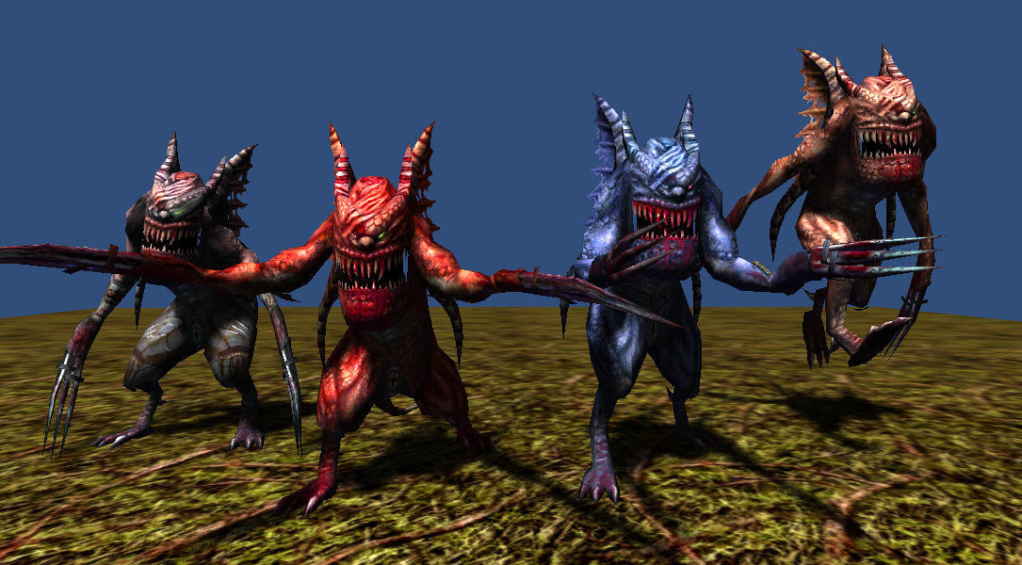

1914 polygons

512x512x32bit 1 texture

6 animations(idle, move, attack1, attack2, beaten, die)

**Thank you for download.**

**Contact**

Homepage : http://www.studioez.net

E-Mail : admin@studioez.net